

Ahsanullah University of Science & Technology

Department of Computer Science & Engineering

Course No:CSE2214

Course Title:Assembly Language Programming Sessional

Assignment No: 01

Date of Performance: 02.02.2020

Date of Submission: 09.02.2020

Submitted To: Ms.Tahsin Aziz & Ms. Anika Sayara

Submitted By-

Group: A2

Name : Mubina Ashrafi

Id : 18.01.04.030

Section: A

Question No: 01

Question: Draw the diagram of Intel 8086 Microprocessor organization.

Answer:

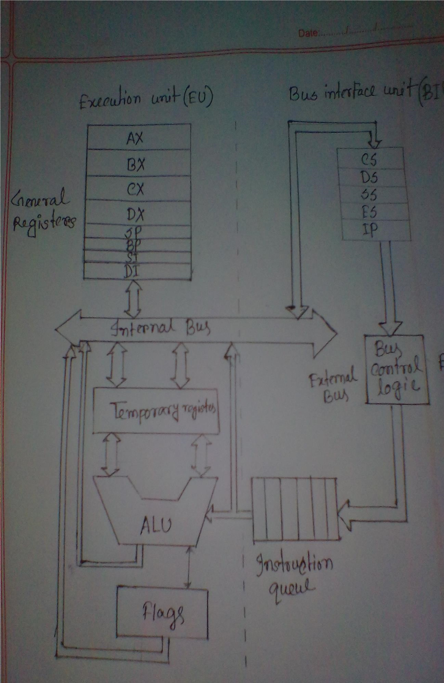

Question No: 02

Question: Consider a machine language instruction that moves a copy of the contents of register AX in the CPU to a memory word. What happens during the fetch cycle and execution cycle.

Answer: The steps of Executing an instruction that moves a copy of the contents of register AX in the CPU to a memory word:

Fetch Cycle:

1. Fetch the instruction: To start the cycle, first the BIU read the request on the control bus and the address of the instruction on the address bus. Memory responds by sending the contents of the memory locations of the register AX over the data bus.

2.Decode the instructions: Receiving the instructions, the decoder circuit of EU decode the instructions and convert into machine code

Execution Cycle:

1. Perform the operation: The EU performs the copy operation on the contents of the registers AX.

1. Store the data: Store the contents of register AX to a memory.